Submission Proposal For Green Candy Press

To The Editor:

The Mycology of Cannabis
by
Kyle Kaszynski and Brandon Potter
Overview:
The primary goal of this book is to educate the cannabis industry on the intricate interactions between fungi and the cannabis plant. As cannabis and medical marijuana gain mainstream acceptance, the demand for reliable information to educate consumers will inevitably increase. Currently, the cultivation community is often plagued by misinformation, perpetuated largely by online forums. This book aims to address these issues by providing accurate and accessible information.
The book will begin with a comprehensive overview of fungi, covering their fundamental biology, growth patterns, and diverse ecological roles. Following this introduction to fungal biology, we will delve into the specific interactions between fungi and the cannabis plant. This section will open with a discussion of beneficial symbiotic relationships, exploring how both the plant and the fungus mutually profit. Key examples such as mycorrhizal fungi and fungal endophytes will be examined in detail.
Subsequently, we will address fungi that are commonly present in cannabis environments. While these fungi may not directly interact with the cannabis plant, they exert significant influence. This segment will cover common soil fungi and fungi crucial to composting and fermentation processes. Additionally, we will briefly explore other fungal associations, including lichens and dark septate endophytes.
A critical focus of the book will be fungal pathogens, a topic of paramount importance to cannabis cultivators. Fungal diseases represent a major challenge for cannabis farmers. By providing a thorough understanding of fungal biology, growth, and life cycles, this book will empower growers to more effectively manage these resilient organisms in their gardens. This section will offer in-depth information on the biology of prevalent fungal pathogens, such as powdery mildew, Botrytis, and damping-off fungi. Furthermore, we will critically evaluate available antifungal products, discussing their effectiveness and modes of action.
The concluding section of the book will equip readers with practical techniques for working with fungi. This will include methods for identifying fungi on plants and in soil, as well as culturing and propagating fungi for the production of fungal inoculants. Given its importance in mycology, the use of microscopes will also be covered, emphasizing their value and providing guidance on their proper application.

Table of Contents:

Introduction to The Mycology of Cannabis
Section 1 Introduction to Mycology
Chapter 1 What is Mycology- Introduces readers to the subject of mycology.
Chapter 2 Fungal Characteristics- Discusses traits and morphologies unique to the fungal kingdom
Chapter 3 Fungal growth- Describes the two primary growth morphologies found in fungi
Chapter 4 Fungal lifestyles- Covers major fungal life styles such as: mutualistic, commensal, parasitic, and saprophytic
Chapter 5 Fungal taxonomy- Introduces readers to basic taxonomy and why nomenclature is important in mycology
Chapter 6 Fungal Reproduction- Educates readers about how fungi reproduce and why they are so successful

Section 2 Beneficial Fungi
Chapter 7 Mycorrhizae- Fungi that grow into or around plant roots that help the plants gain resources while giving the fungus carbon in return
Chapter 8 Fungal Endophytes- Fungi that live inside the tissue of plants without causing any apparent harm
Chapter 9 Saprophytic fungi- Fungi that degrade dead organic materials and are the worlds ‘grand recyclers’
Chapter 10 Entomopathogenic fungi- Fungi that are carnivorous and can consume insects as a food source
Chapter 11 Fungi as viral vectors- Studies have shown that certain fungi can act as a vector, infecting plants with beneficial or pathogenic viruses and viroids

Section 3 Fungal diseases
Chapter 12 Powdery Mildew- Fungal disease caused by Podosphera species
Chapter 13 Bud-rot- common Fungal disease in mature flowers caused primarily by Botrytis cinerea
Chapter 14 Damping off- Disease which commonly infects newly emerged seedlings, quikly killing the plant
Chapter 15 Crown & root rot- Includes many fungal diseases such as Fusarium wilt
Chapter 16 Hemp canker- Fungal disease unique to cannabis cultivators
Chapter 17 Leaf spots- A once rare fungal disease in Cannabis culture, this disease can display symptoms that may look like nutrient issues
Chapter 18 Post-harvest contamination- Even after Cannabis plants have been harvested, fungi can still contaminate products if it is not dried and stored properly

Section 4 Defending Against Fungal Pathogens
Chapter 19 Plant defenses- Plants have the natural ability to defend themselves against fungal pathogens
Chapter 20 Prevention of disease outbreaks- The key to preventing disease and crop loss is to prepare and prevent fungal pathogens from infecting your garden
Chapter 21 Aerial and Foliar Treatments- If fungi do infect plants, here are some tried and true methods for minimizing crop loss

Appendices:
Glossary
Relevant Fungal Taxa
Common Fungicides allowed in Cannabis production
Cultivation protocols
Bibliography
About Us

About Us:

Kyle completed a bachelor’s degree in Plant Biology with a minor in chemistry from Southern Illinois University. He then received a master’s degree from University of Wisconsin-La Crosse in Mycology where his master’s thesis was focused on sustainable cultivation of edible mushrooms. Kyle has been experimenting with Cannabis cultivation and organic agriculture for over 15 years. Mr. Kaszynski has worked in hydroponic garden stores, consulted and worked in research and development for several fertilizer companies, and is certified crop advisor, certified lab technician with the Soil Food Web and is the lead mycologist for several companies.

Brandon received a B.Sc. in Biology from the University of North Carolina at Asheville. He remained in Asheville to work as a research technician with the United States Forest Service at Bent Creek Experimental Forest several years following. After which, he received a M.Sc. in Biology from the University of Wisconsin -La Crosse. Throughout his life and education he was drawn to the fields of botany and agriculture which led naturally to plant pathology and mycology. In addition to a formal background in biology and scientific research, Brandon has over 15 years experience in growing and working with Cannabis across a large variety of cultivation styles and scales. He has been breeding autoflower cannabis strains and producing seeds for the past 8 years.

Sales/Marketing:

This book will be a comprehensive guide to fungi that interact with the Cannabis plant. The target audiences will be Cannabis cultivators and enthusiasts from a non scientific background, as well as students and educators. There is not much science-based literature about Cannabis cultivation and as the plant becomes more widely accepted and cultivated there will be a need for resources like our book.

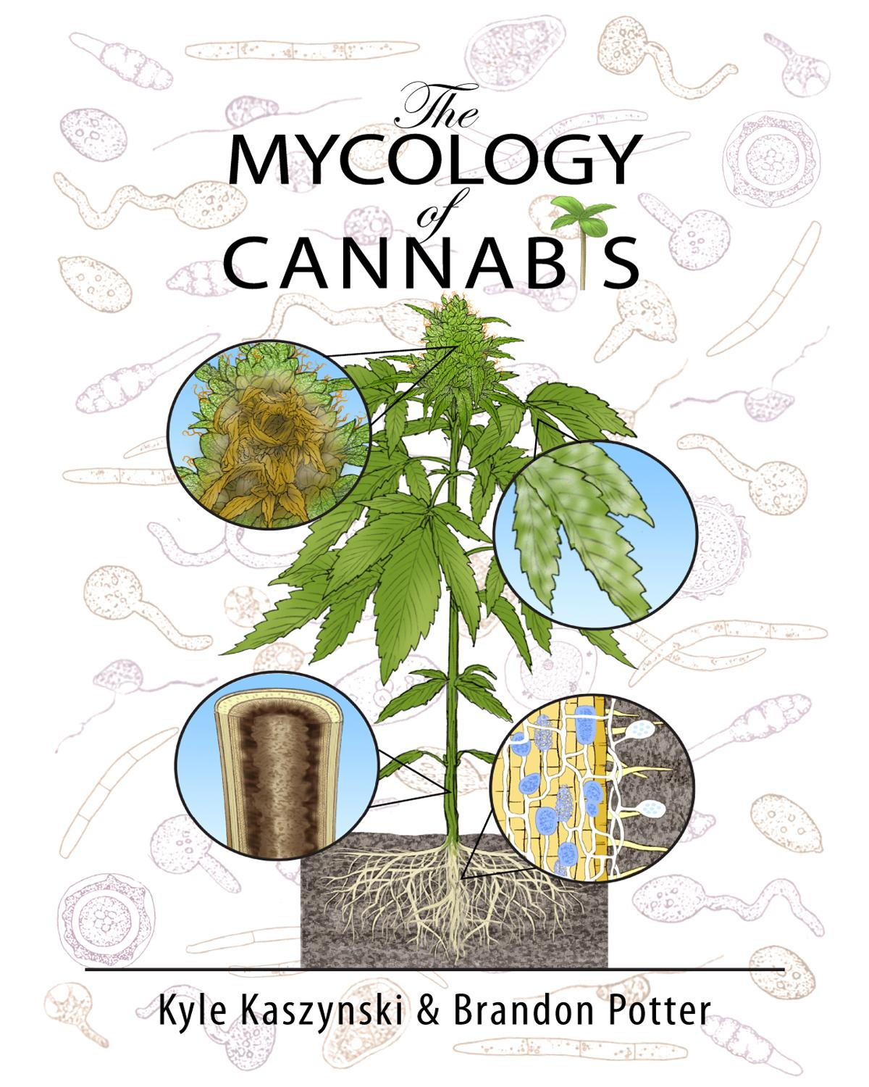

Sample Chapter
Chapter 2
Fungal characteristics

Gowers Notes:
· Fungi reproduce via spores
· Fungi are a distinct lineage from both plants or animals, though are closer related to animals than to plants
· Fungi have cell walls that are chemically different (composed of chitin) than the cell walls of plants (composed of cellulose)
· Fungi do not produce their own food so must release enzymes to break down complex food sources and the reabsorb the nutrients

Some physical and physiological characteristics of fungi can be useful in identifying fungi to various levels of hierarchical classification. Farmers with an understanding of fungal characteristics are also at an advantage in manipulating them to the benefit of their crop. In this chapter we will be discussing different anatomical features that researchers and growers can use to help identify the particular fungus with which they are working. We will be describing some of the key features that make a fungus a fungus, and not, for instance, a plant. The goal of this chapter is to educate readers of fungal traits.
Historically fungi have been grouped closely with plants. To this day, within academia, fungi are generally reserved for the purview of the botanists. Universities with a “Department of Mycology” are exceedingly rare. When a university department or college does include “mycology” in its title, it is almost always paired with the “botany” or “plant pathology” department. Though in hindsight there is an unintentional logic behind this, as these two kingdoms are intimately linked in practice through symbioses, the original grouping of fungi and plants together was an academic mistake.
Fungi superficially grow similarly to plants, with macroscopic forms appearing as sessile organisms with cell walls similar to plants and dependent on dispersal of reproductive structures for survival. Botanists, beginning with Pier Antonio Micheli, who published Nova plantarum genera in 1729, were the first western scientists to pioneer the study of fungi. Pier Antonio Micheli was the first person to show fungi reproduce via spores. Before his experiments showing that spores transferred to a new substrate gave rise to the same species of fungi from which they came, the dominant view had been that fungi spontaneously generate.
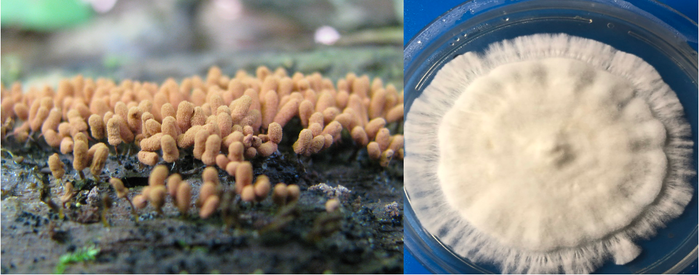
Fig. 2.1 Slime mold (left) vs a true filamentous fungus, Psilocybe spp. (right).
Throughout most of history fungi were considered lower plants. Ironically, this tradition of grouping unrelated organisms within an unrelated field continues; the Amoebozoid ‘slime molds’ (Myxostelida, Dictyostelida, Labyrinthulida, and Plasmodiophorida) and the Chromistan ‘fungi’ (Fig. 2.1) are not true fungi. Nonetheless, the similarity of physical appearance, growth characteristics, and economic impacts of these organisms reinforce their retention as a related field to mycology (and likewise mycology to botany).

Table 2.1. Hierarchical classification of 3 domains of life.
Domain | Kingdom | Members
Bacteria | Bacteria | Actinobacteria (Actinomycetota), Proteobacteria (Pseudomonadota), Cyanobacteria (Cyanophyta), Spirochaete (Spirochaetota), ect.
Archaea | Archaea | Extremophiles, methanogens
Eukaryota | Excavata | Various flagellate protozoa
 | Amoebozoa | Most lobose amoeboids and slime molds
 | Opisthokonta | Animals, fungi, choanoflagellates
 | Rhizaria | Radiolaria, and various other amoeboid protozoa
 | Chromalveolata | Stramenopiles (Brown Algae, Diatoms etc.), Haptophyta, Cryptophyta (or cryptomonads), and Alveolata
 | Archaeplastida | Land plants, green algae, red algae, and glaucophytes

Plants and Fungi
The relatedness of fungi and plants has stumped scientists for generations. In the past, scientists were only able to observe morphological characteristics in these organisms and did their best to group them based on these features. Chemical taxonomy helped prove that fungi were physiologically distinct from plants in numerous ways (Figure 2.8). The aid of molecular genetic sequencing techniques has recently helped further unravel the many mysteries about the relatedness of fungi. Organisms once believed to be fungi have been reclassified as protozoa (including oomycetes and the mycetozoan slime molds,); organisms believed to be protozoa (such as Chytrids, Microsporidia, and Pneumocystis jirovecii) were shown to be fungi. Protozoa itself is a catch-all group of single celled organisms that is non-monophyletic, meaning the grouping contains organisms descending from separate ancestral lines. Therefore it serves only as a classification rather than a systematic grouping representing phylogeny.
As stated before, plants and fungi share a number of similar characteristics but there are also some key differences between the two. To begin, both organisms are eukaryotic with membrane bound organelles, including a nucleus that houses the genetic material, deoxyribonucleic acid (DNA). However, fungi have relatively small nuclei with little repetitive DNA. Fungi can have one to many nuclei per ‘cell.’ Often these are genetically distinct nuclei when plasmogamy (the fusion of independent mycelial bodies) has occurred in the individual's history. Previously, separate individual mycelia may merge together in this way if they have appropriately-matched vegetative or mating compatibility types. Fungi usually have haploid
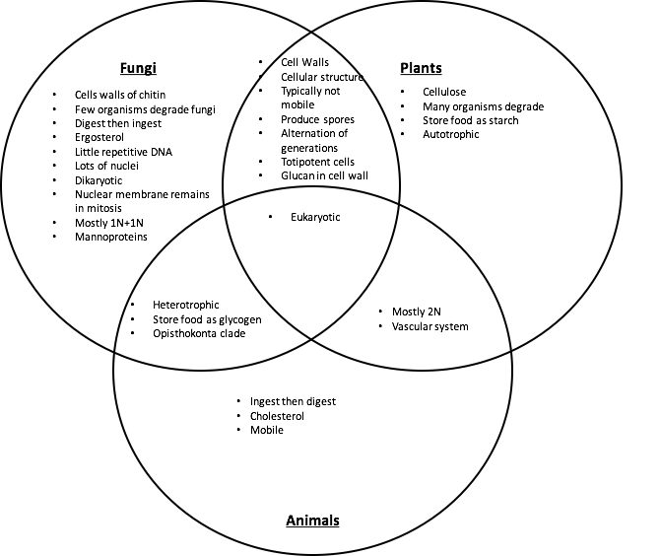
Figure 2.2. Venn diagram comparing similarities and differences of fungal, plant, and animal characteristics.

nuclei, even when two (or more) genetically unique nuclei coexist in an individual. Karyogamy (nuclear fusion) resulting in 2n nuclei only occurs in certain cells within fruiting bodies. These 2n nuclei form preceding the sexual production of gametes via meiosis. Higher plants have relatively large nuclei that are often diploid in all cells except the gametes, pollen and ovules. This is similar to animals.
A structure that both plant and fungal cells produce, and which serves many of the same functions, is the cell wall. The cell wall permits both plants and fungi to form sturdy structures capable of above ground growth by adding rigidity to tissue. Cell walls also assist in growth through physical substrates by permitting turgid fungal hyphae and plant tissue to exert outward osmotic pressure without the cell membrane rupturing. This is a crucial factor for the apical growth of hyphae among fungi through a physical substrate (Money, 1995), as it is in root tips and pollen tubes among plants. Additionally, cell walls serve to protect the cellular components and organelles found within. Despite similarities in function, the composition of the cell walls fundamentally differs between plants and fungi. Plants have cell walls composed of cellulose (and sometimes lignin) whereas fungi have cell walls of chitin.

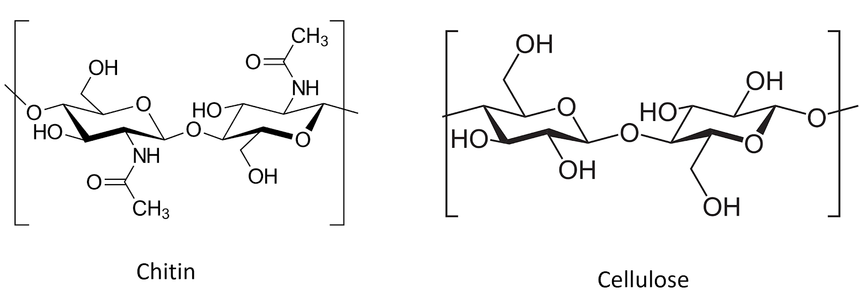
Figure 2.3. Chitin and cellulose are both polysacharide chains of β1-4 linked monosacharide monomers. Chitin comprises chains of N-Acetylglucosamine monomers, whereas cellulose is made of D-glucose monomers (graphic from wiki commons).

Due to the rigidity of the cell walls, both plants and fungi are generally sessile (non-motile) when mature. As sessile organisms, the lifestyle of plants and fungi are much different because of how each must acquire food. Plants are photoautotrophic and therefore able to produce their own food by utilizing sunlight energy to fix atmospheric carbon via photosynthesis into sugars. They also rely on root systems to gather essential elemental nutrients from the medium in which they grow. Plants metabolize sugars via cellular respiration as a source of stored energy. They also use the sugar they create, along with elemental nutrients from the soil, as substrates to synthesize the complex organic compounds their bodies require to live. In contrast, heterotrophs are unable to produce their own food and must acquire nutrition and carbon from the consumption of other organisms or their byproducts.
Fungi are chemoheterotrophic, meaning they must acquire organic carbon (rather than inorganic carbon dioxide) from the environment. These acquired nutrients serve as both their source of chemical energy and the necessary substrates from which their cellular machinery and bodies are produced. They are entirely reliant on acquiring nutrients and food from the environment.
Ultimately, all of every* fungus’s food is directly or indirectly sourced from carbon based molecules produced from the fixation of atmospheric carbon dioxide (CO₂) by plants. The same is true for ourselves as humans, as well as every other heterotrophic organism (save those lifeforms whose food is derived from the action of prokaryotic chemoautotrophs, such as the extremophiles which survive in sulfur springs or form the basis of the food webs of deep sea vents.).
*Of course “every” implies an absolute term. Biology resists absolutes and every rule will turn out to have exceptions. For example the “central dogma” of molecular biology included the word dogma because, Francias Crick when naming his hypothesis, considered the word to mean a belief for which there was no supporting evidence
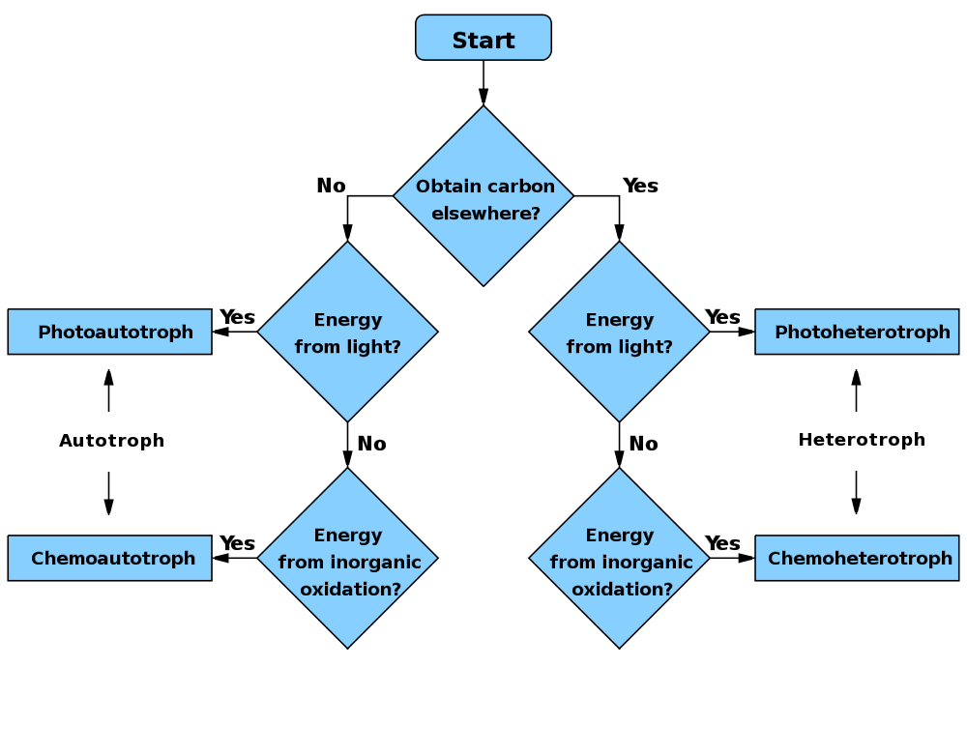
Figure 2.4. Flow chart comparing autotrophic (make their own energy source vs heterotrophic (must service carbon energy from outside of organism). WikiCommons user: Wickey-nl

While fungi are generally ‘non-motile,’ their cells are connected in such a way as to allow much of the cytoplasmic contents to flow through the tubular hyphae. In this way, a fungus can transport nutrients around its mycelium. While a fungus cannot move its existing body to a new location, they are able to exploit cytoplasmic flow in order to change or expand locations by growing hyphae in new directions, flowing their cytoplasm into the newly formed mycelial body, and walling off older sections of their mycelium.
Another implication of being unable to move is that fungi, like plants, cannot evade predators. Therefore, they are forced to come up with alternate defense mechanisms. Plants can develop thorns and spikes as part of their physical structure to discourage predators from attacking, however, they also produce a variety of novel secondary metabolites that act as defense compounds. Some fungi have developed physical defense structures, such as lacticifers among Lactarius or the physical toughness of many perennial polypores, but the production of secondary metabolites to ward off competitors or predators is ubiquitous. Some of these compounds include famous antibiotics, such as penicillin and its derivatives, or citric acid , a common food additive that is produced from Aspergillus niger fermentation. The plethora of secondary metabolites from fungi is astonishingly diverse and includes varying polyketides, terpenoids, terpenes, alkaloids, and peptides (Keller et al, 2005).

Animals and Fungi
There are a number of other key similarities and differences in plants and fungi, however, fungi are actually closer to animals than plants (Figure 2.2). Animals, plants and fungi are all eukaryotic, with DNA contained in a nuclei and membrane-bound organelles, representing their common lineage. However, plants split away from the ancestors of fungi and animals first. Today, fungi and animals are both placed within the clade Opisthokonta. A common trait of this clade is mobile gametes at some point in the organisms’ lifecycle. Only the basal lineages of fungi have retained motile gametes, as have humans (sperm). Most fungi no longer produce flagellated gametes.
Obviously, most animals are mobile organisms that are adept at moving around to find nutrients and food, and evade predators. The lack of cell walls is important for permitting contraction and relaxation of muscle cells, on which animal movement depends. The relative rigidity of mature fungal cells conferred by cell walls prevents contractile-relaxation of tissue, as well as ameboid-like formation of pseudopodia.
Both animals and fungi are chemoheterotrophic. In general, neither can produce their own food and cannot use light as an energy source. Thus, animals will ingest and then digest their food, whereas fungi digest (by releasing exoenzymes into the environment) and then ingest (by actively transporting nutrients back into the fungal body).
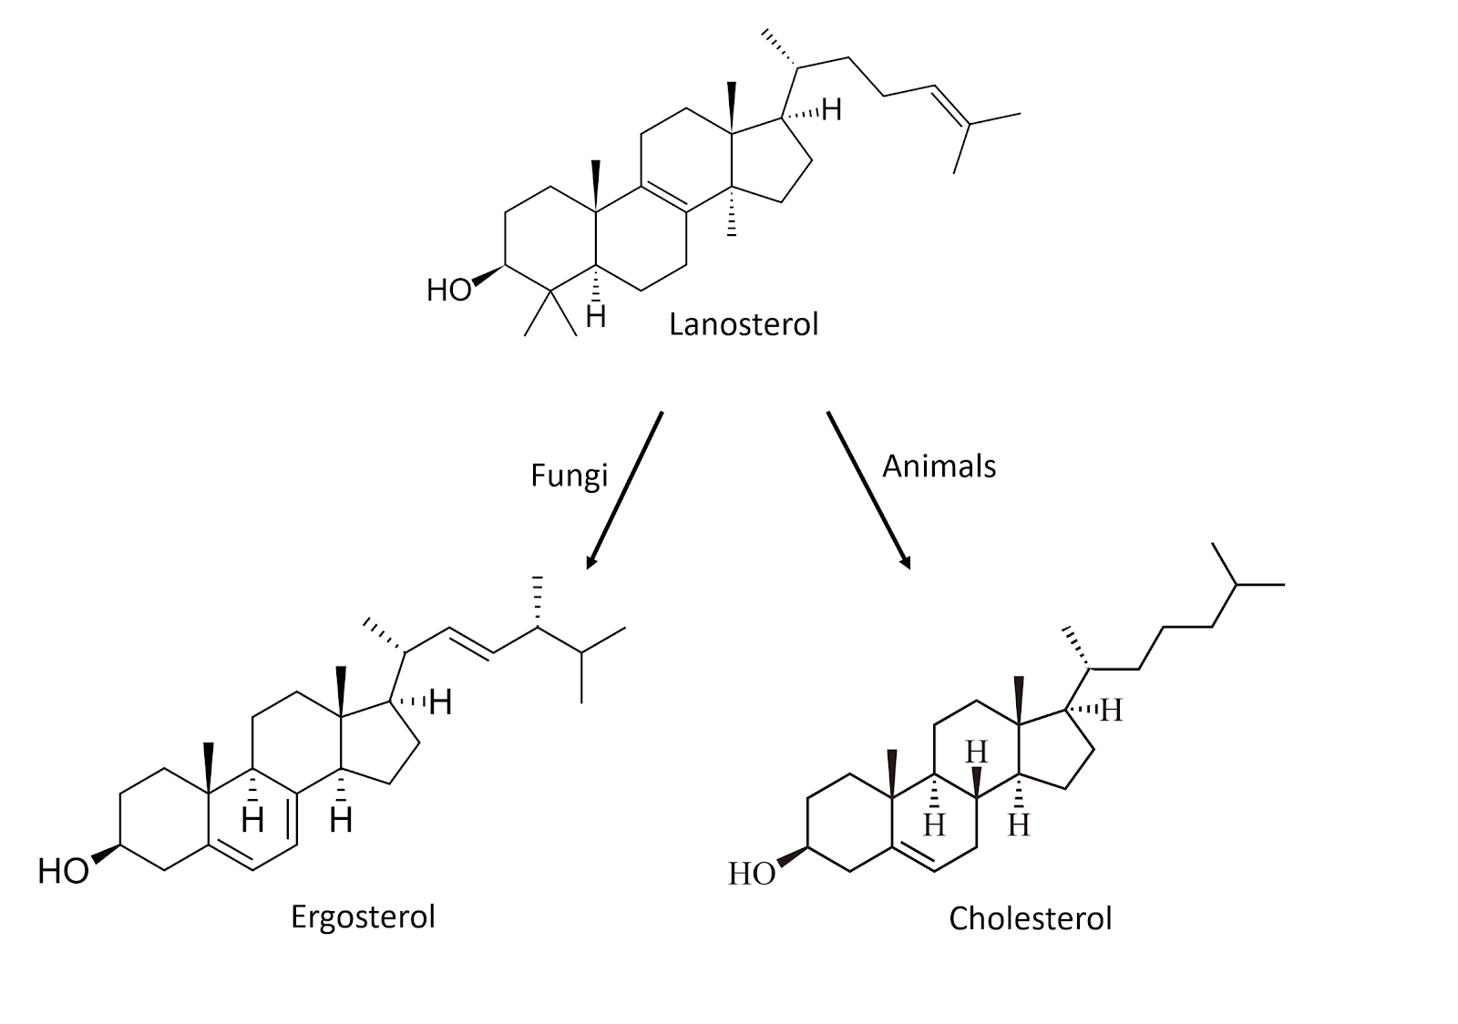
Figure 2.5. Chemical structures for sterol compounds found in fungi (Ergosterol) and animals (Cholesterol).

A physiological difference with practical implications between fungi and animals is the structure of sterols embedded in their cell membranes. Fungi synthesize ergosterol whereas animals synthesize cholesterol (plants also produce a diverse array of phytosterols). Both ergosterol and cholesterol are derived from the same precursor, lanosterol (Figure 2.5). Ergosterol and cholesterol serve similar functions including impacting membrane fluidity, cell signaling and other physiological processes.
One reason we are focusing on this particular molecular difference between fungi and animals is that we can exploit the ergosterol pathway unique to fungi in order to develop and apply selective fungicides. Compared to prokaryotic pathogens and disease agents, parasitic and pathogenic fungi have much more in common physiologically with their eukaryotic plant and animal hosts. Therefore, ergosterol and its biosynthesis are particularly important targets for antifungal compounds in agriculture, as well as veterinary and human medicine.
Fungi are an extremely unique and diverse group of organisms that contain some characteristics not found anywhere else in nature. The varied growth forms are reliant on external digestion of substrate by secreted exoenzymes, followed by ingestion of the predigested food via absorption and endocytosis. That fungus can be mono- or dikaryotic, some with many nuclei per ‘cell,’ is not only fascinating, but allows fungi unique physiological and evolutionary paths compared to uninucleate organisms.
Also, among filamentous fungi, cells can behave a little differently than one usually thinks of when considering traditional biological cell; the entire vegetative body, the mycelium, can exist as a complex network which nevertheless functions as though it is a single cell due to the ability of its cytoplasm to flow freely. Yeast cells are more akin to what most people think of when pondering single-celled organisms.
In summary:
· Fungi reproduce via spores
· Fungi are a distinct lineage from both plants or animals, though are closer related to animals than to plants
· Fungi have cell walls that are chemically different (composed of chitin) than the cell walls of plants (composed of cellulose)
· Fungi do not produce their own food so must release enzymes to break down complex food sources and the reabsorb the nutrients
The physical traits (morphology) can be used to help identify fungi to a certain extent

Chapter 3

Fungal Growth

Grower’s Notes:
· Fungi can grow as a yeast or in a filamentous form, sometimes both
· Fungi do not produce their own food so must release enzymes to break down complex food sources, then ingest the predigested nutrients into their bodies
· Filamentous fungi grow from the apical tips to eat food and colonize new spaces

This chapter will describe how fungi grow and obtain nutrients and other resources from the surrounding environment. Fungi are unique organisms that have features not found elsewhere in biology. Therefore it is important as cultivators to understand how fungi grow in hope of encouraging growth of beneficial fungi while inhibiting the growth and presence of fungal pathogens.
There are two main types of growth forms that fungi display; filamentous and yeast. The body of filamentous fungi is made of thin, thread-like, typically cylindrical cells that are extensively branched called hyphae (sing. hypha). These cells allow filamentous fungi to penetrate through substrates. All of the hyphae from an individual fungus is collectively called mycelium (plural mycelia when referring to more than one fungal individual). The mycelium is the vegetative body of the fungus and is the necessary form for the filamentous fungi to collect nutrients and water.
Yeast are single celled fungi, usually spherical, that do not form hyphae. Some fungi can take on a yeast or a filamentous form, depending on the growth stage and environmental conditions. Fungi capable of this versatility in form are referred to as dimorphic.
Yeast forms exist as single cells that replicate via budding or fission, creating two exact genetic copies of itself from a single mother cell. In this way, vegetative growth in yeast is characterized by asexual reproduction of individual cells, rather than growth of a single contiguous hyphal body. Many yeast can also reproduce via sexual replication. Yeast fungi are quite ubiquitous, albeit underappreciated, especially in agriculture settings

Filamentous fungi
Filamentous fungi eat and grow simultaneously. They do so by releasing enzymes ahead and out of the growing hyphal tip, then pushing through their food as they consume it. To coordinate the release of enzymes, filamentous fungi have an organelle-like structure that is called a spitzenkorper at the apex of growing hyphae. This microtubule-dense organizational center delivers vesicles full of enzymes directly outside the growing fungal tip. This external enzyme bath breaks down complex materials into more fundamental, nutritive molecules which are then accessible for endocytosis or direct absorption by the fungus (Steinberg 2014). Additionally, the breakdown of solid substrates clears a path for physical growth of and occupation by the fungus.
Once inside the hyphae, molecules are further broken down and metabolized by the fungus for all of its life functions and growth, including synthesizing proteins, cell walls, hormones, etc.. This is how a fungus ‘eats’, consumes resources, and grows.

As the keen mycologist Tom Volk often explains, “it would be as if I went to a 5 star restaurant and ordered the surf and turf (or tofu surprise) and then when the meal came I vomited all over the dish and then stuck my hands over the mess to absorb the nutrients back into my body.” Quite the image.

Another trait that some filamentous fungi possess is having septa. Septa are crosswalls that some fungi produce behind the growing tip in order to divide the hyphae into different ‘cells’. These septa are perforated, allowing some organelles to pass while blocking others. Because many groups of fungi allow the movement of so much of their cellular contents, sometimes including nuclei, the individuality of each cell isn’t always clearcut.
There are two different types of septa that are found in fungi; simple porate septa and dolipore septa. These different septa morphologies can be used to distinguish the phylum that the fungus is located in. Fungi in the phylum Basidiomycota have what is called a dolipore septum, often along with a clamp connection. This type of septum has membranes covering the central pores, allowing for the fungus to maintain its dikaryotic state (2 types of nuclei per cell) while still allowing small organelles and chemicals to flow through with the cytoplasm. Fungi in the phylum Ascomycota have simple porate septa. These septa have no membrane to block organelles from passing from one cell to the next. Therefore, large, unbound organelles, including nuclei, are free to travel through the septa. Some groups of fungi lack any septa at all (or only have them adventitiously), including the ‘Zygomycota’ (bread molds), Glomeromycota (endomycorrhizae), and the Chytridiomycota (includes the causal agent of chytridiomycosis). When the hyphae does not have septa it is termed coenocytic or aseptate.
The unrestricted connectivity within the body of coenocytic fungi and ascomycetes permit them to function as single, multinucleate cells. Often fungi have a high density of nuclei at the growing tip where the demand for gene products may be particularly high. Fungi can fuse with compatible fungi and exchange nuclei and cytoplasm. The resulting genomic variation among nuclei within a single fungi permits these types of fungi more phenotypic plasticity to adapt to the environment in which they are growing than would a mononucleate fungus or even a simple dikaryon. Transfer of nuclei, followed by recombination or chromosome donation, may also serve as an important source of genetic novelty during fungal evolution, particularly among fungi not known to undergo sexual reproduction (Roper et al, 2011). This can occur even among distantly related species.

Some filamentous fungi will produce a fruiting body collectively called a mushroom. A mushroom is simply a reproductive structure that certain fungi have evolved to produce. In general, edible mushroom producing fungi are not physiologically involved with Cannabis. However, some applications of mushroom producing species may be beneficial in Cannabis agriculture. For example, Pleurotus osreatus, the common oyster mushroom, can be cultivated on the dead biomass of Cannabis plants (the stems, the leaves). Another example of a mushroom producing fungus that aids in Cannabis cultivation is Stropharia rugosa-annulata or the garden giant (aka wine cap). This fungus is particularly good at decomposing organic materials such as wood chips or straw and is commonly inoculated in garden beds. In addition, planting mushrooms near cash crops also recruits other biology to the soil system. Using the garden giant will help aid in nutrient cycling, improve soil structure, and may release compounds that influence plants and/or soil biology. https://www.ncbi.nlm.nih.gov/pmc/articles/PMC4358370/
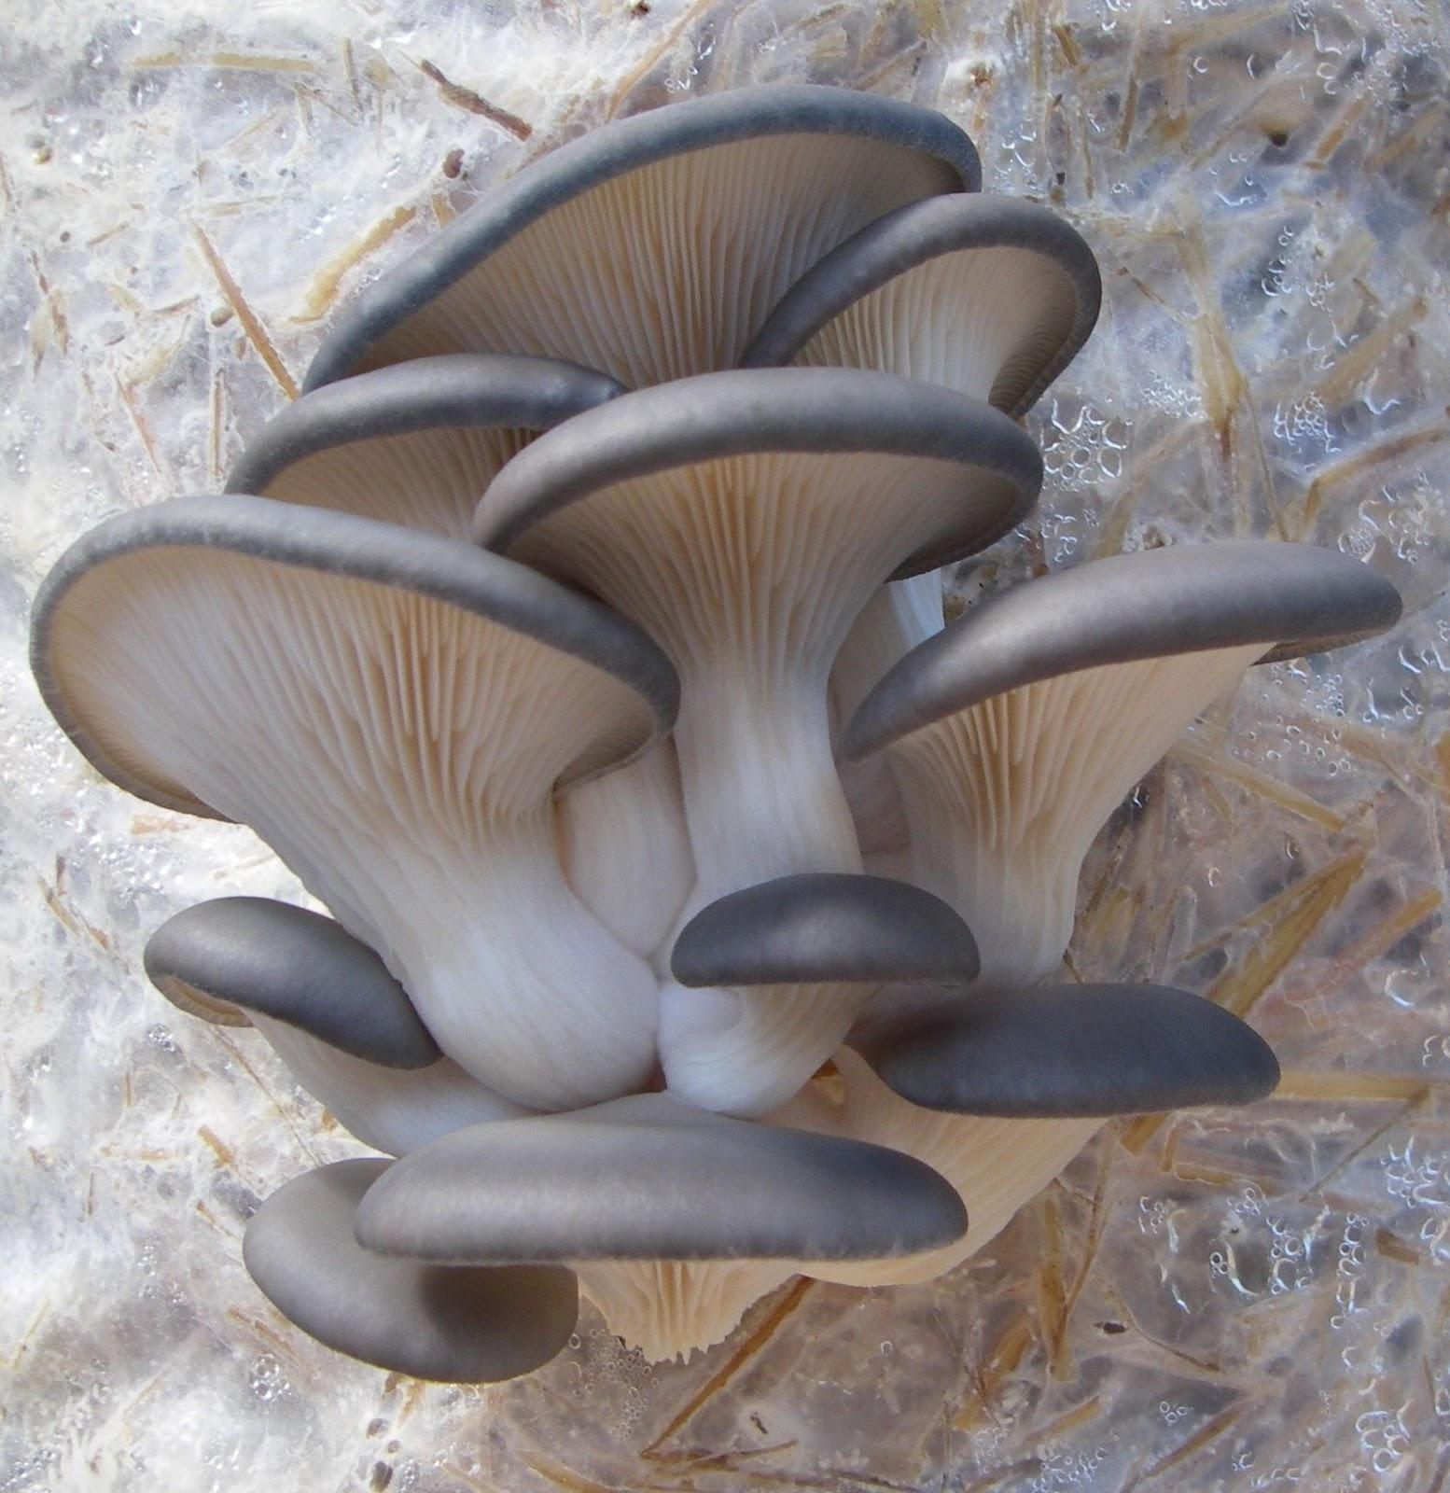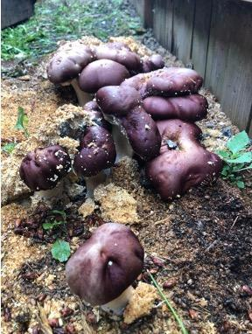
3.1a Oyster mushroom fruiting off straw. 3.1b Wine cap fruiting out of soil.

Currently there is some misinformation going around in the Cannabis industry in relation to soil fungi and compost tea. There have been claims made by some who state that if a fungus has septa, then the fungus is beneficial and will help with decomposition and plant growth. However, if the fungus does not have septa (coenocytic), then it is a pathogenic fungus and will kill plants and harm your soil community. While there are some instances where this may be true, this is a broad over-generalization and septa alone should not be used to identify beneficial vs pathogenic fungi. Possibly, what people are referring to is Oomycetes, or water molds, which are coenocytic, pathogenic, and are also not true fungi. Many useful and beneficial fungi lack septation, including members of the Glomeromycota, and Zygomycota.

Yeast fungi
Yeasts truly are single celled fungi. An individual yeast cell is very small and cannot be seen with the naked eye. Yeasts are ubiquitous and are found throughout the world and in a range of habitats. The most famous yeast, Saccharomyces cerevisiae or the brewers yeast, is used not only to brew delightful beverages but also to bake bread. The same species (but different varieties/strains) are used for both processes. Thus, humans and yeasts have a relationship longer than written history. Saccharomyces cerevisiae is also a model organism used in scientific research. As an easily culturable and resilient eukaryote, it has proven to be extremely useful to humans on a number of counts. On the other end of the spectrum, some species of yeasts are capable of causing serious diseases among humans, including Crypotococcus neoformans, which is also a potential endophyte of Cannabis and the cause of cryptococcosis.

Yeast are very difficult if not impossible to identify simply by looking at a microscope. There are some yeasts that display unique physiological traits that allow them to be identified by simple observation, but many need to be subjected to metabolic tests or, the most rigorous method of identification currently available, by using molecular techniques.
Even though yeasts may be hard to see and often go unappreciated, they too play an important role in the soil and in agriculture in general. The full role that yeasts play in soil and on above ground biomass of plants is poorly understood, but what we do know is that they are present whenever we look for them. These single-celled fungi help decompose organic matter, act as a food source for other soil life, produce novel metabolites, influence plant growth, and help shape the soil structure. Without them, the soil, and therefore the plants, would behave very differently.

Conclusions
Fungi either grow as a unicellular yeasts, have a filamentous body of hyphae collectively called mycelium, or may switch between these forms. Filamentous growth offers certain advantages over yeast forms for the performance of particular tasks. The absorptive eating strategy employed by fungi benefits from a highly branched, fast expanding body with favorable surface ratio for the exploitation of an abundant food resource. As digestive enzymes released from the growing tip of the fungus, the hyphal body can absorb the products of the substrates decomposition via endocytosis.
Filamentous fungi may also differentiate into specialized structures and have complex patterns of nutrient transport and metabolic coordination. This can be particularly useful when claiming territory and food resources over long periods of time. Some filamentous fungi can grow perennial structures that persist and function for years and even decades. However, being small and simple in design has its benefits as well. Yeasts are capable of reproducing at an extraordinary rate. Because they are just a single cell, everything the organism needs to survive and reproduce is kept in every cell.
As you can see, fungi can be quite diverse in appearance both macroscopically and microscopically. While these differences have proven useful as diagnostic features for the identification and classification of organisms, the true utility of these features is to allow fungi to specialize and exploit various ecological niches. Now let us explore further how fungi live, grow, and gather nutrients from their environment.
In summary:
· Fungi can grow as a yeast or in a filamentous form, sometimes both
· Fungi do not produce their own food so must release enzymes to break down complex food sources, then ingest the predigested nutrients into their bodies
· Filamentous fungi grow from the apical tips to eat food and colonize new spaces

Chapter 4

Fungal Lifestyles

Grower’s Notes:

- Saprophytic fungi degrade dead organic materials
- Mutualistic fungi live in symbiosis with another organism where both members are benefiting
- Commensal symbiosis is when 2 organisms live together and only 1 partner is benefiting but the other partner is not harmed in any way
- Parasitic fungi steal nutrients from a living host organism

Fungal lifestyles are an important aspect of plant-fungi interactions which will determine a farmers relationship with each fungal species they encounter. Many fungi are helpful to farmers. Some serve to cycle nutrients from organic matter and access those trapped in parent rock material. Others colonize the surfaces and internal tissues of plants. Most of these relationships benefit their host plant in myriad ways, or at the least do not cause any apparent harm.

Growers Notes:

Often, the fungal lifestyle most familiar to farmers is one that manifests as a conspicuous loss of crop to disease. Disease causing fungi of Cannabis are those that live as pathogens, causing harm to their host plant in order to obtain nutrition from it. Understanding the different strategies of fungi found on your farm will allow more adept control over their manipulation so that pathogens may be minimized while beneficials can be optimized.
Fungi are heterotrophic, reliant on acquiring nutrients from the environment they live in for their metabolic demands. As such, fungi typically fit among three different types of lifestyles that they use to get nutrients. Those lifestyles are saprophytic (fungi that degrade dead organic material), parasitic (fungi that live on another living organism and cause the host some degree of harm) and mutualistic (meaning there are benefits to both the fungus and its symbiont). In addition to these lifestyles, there are some predacious fungi that derive all or part of their nutrients from carnivory; they do so by trapping soil inhabiting invertebrates using specialized hyphae. Many fungi readily switch roles among these trophic strategies from parasite, to mutualist, to saprophyte, to predator, and back again as it suits their needs and abilities.
Saprophytes are very important in all ecosystems because they are the ‘grand recyclers’ and utilize dead material to make locked up nutrients available for other organisms to utilize. Therefore, saprobes play an important role in nutrient cycling. This makes these fungi very important for organic Cannabis agriculture.
The garden giant (Stropharia rugosa-annulata) is one example of a fungus that is often incorporated into raised garden beds. The mycelium is mixed with pasteurized straw or wood chips and then used to cover the soil on the garden bed. This not only cools the soil surface temperature and reduces weeds, but it also cycles nutrients through the soil system to your plants. This occurs because fungi are constantly secreting enzymes that break down complex compounds into simpler molecules that can eventually be assimilated by the plants. The garden giant fungus is also relatively easy to grow outdoors and produces an incredibly tasty mushroom, making it a perfect companion for outdoor plantings with Cannabis.
Other saprophytic soil fungi may benefit plants similarly, as well as improving nutrient cycling, soil structure, water retention, recruiting other biological organisms, and competing with disease agents. Make note that care should be taken to ensure adequate nitrogen availability when adding low nitrogen, high carbon mulch material; in the short term, nitrogen will be pulled from the top layers of the soil by saprophytes as they colonize and degrade new mulch.
Other saprophytic fungi include edible, mushroom-producing fungi such as oyster mushroom, shitake mushroom, and button mushroom. Many soil fungi, including Trichoderma and Penicillium species, are saprophytes that do not produce mushrooms but play key roles in the conversion of organic matter into usable nutrients. If your soil lacks fungal diversity, high quality compost or compost extracts are full of soil microorganisms and is an efficient method for inoculating fungi back to soils.
While saprophytic fungi grow on dead organic matter, parasitic fungi grow on living organic matter. Parasitic fungi can grow on many different organisms, ranging from animals to plants, to even other fungi (Fig 4.1). By definition, parasitic fungi are fungi that derive their nutrients from another living organism with no apparent benefit to the host. Because parasites require a living victim to persist, a well-adapted and specialized parasite rarely kills its host. There are some fungi that act as human pathogens and can cause serious illness, especially in patients that already have a compromised immune system. For instance, athlete's foot and ringworm are both diseases which affect humans that are caused by fungi in the genus Arthroderma. Then there are a lot of other
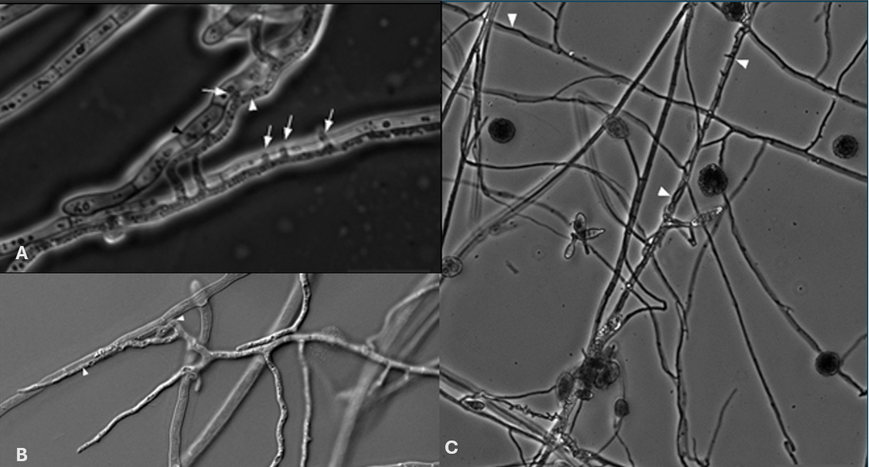
Figure 4.1. An example of a mycoparasitic interaction where Alternaria alternata is attacking the hyphae of Eppicoccum nigrum seen with phase (A and B) and differential contrast interference (C) microscopy.

fungi that act as pathogens to plants. Some of these species of fungi are generalists and can live on a variety of host plants, whereas other species are specialists, growing only on specific host plants. For the Cannabis plant, there are a variety of fungal species that can act as pathogens and they range in the amount of damage to the host (Table 4.1).
Though there are a number of fungi that act as parasites, there are also many that have beneficial relationships with other organisms. This type of symbiosis, where two organisms interact physiologically to form a mutually beneficial relationship, is called mutualism. For example, a lichen is a mutualism where a fungus acts as a mycobiont and an algae or cyanobacteria will act as a photobiont; together they create one organism, a lichen. Another example of this is mycorrhizal fungi. Mycorrhizal (myco- meaning fungus and -rhiza meaning root) fungi form associations with the roots of many different plants and help deliver the plant water, minerals, and nutrients (in particular phosphorus) and in return the plants gives the fungus sugars that it makes in photosynthesis.
Table 4.1. A few of the many important saprophytes, parasites, and mutualists for Cannabis growers
Saprophytes | Parasites | Mutualist
Soil:  - Penicillium spp.  - Aspergillus spp.  - Trichoderma verde  - Trichoderma hazarium  Wood Rot:  - Pleurotus spp.  - Stropharia rugosoannulata  - Pilocybe spp. | Plant pathogens  - Fusarium oxysporum  - Botrytis cinerea  - Golovinomyces ambrosiae  - Podosphaera macularis  - Septoria cannabis  - Alternaria alternata  Mycoparasitic  - Trichoderma verde  - Trichoderma hazarium | Arbuscular (Endo-) Mycorrhizae:  - Glomus spp.  - Rhizophagus intraradices  - Funneliformis mosseae  - R. irregularis  Mucormycoitina Fine Root Endophytes  - Planticonsortium tenua  Endophytes  - Penicillium spp.  - Trichoderma spp.

A fourth type of interaction that we see fungi engage in is called commensalism. This is when one organism uses another organism to its benefit, without causing harm to the other organism. An example of this is when an epiphytic orchid is growing high up in the crevasse of a tree, the orchid has an advantage over other orchids because it is higher up and therefore is closer to sunlight, whereas the tree is not meaningfully affected positively or negatively.
Although these four different types of relationships or lifestyles may seem clearly defined, realistically in nature these relationships are on a continuum. These four different lifestyles that we just described (Saprophyte, parasite, mutualism and commensalism) are all terms that were created by humans to help us understand nature. However, nature is not confined to such borders and therefore we see some organisms that are mutualists at one point in their life, and then they switch to being a parasite, and eventually they act as a saprophyte because the organism is consuming the dead host that it just parasitized. So, although we do our best to describe and make sense of nature, we always have to remind ourselves that nature doesn't always follow our rules.
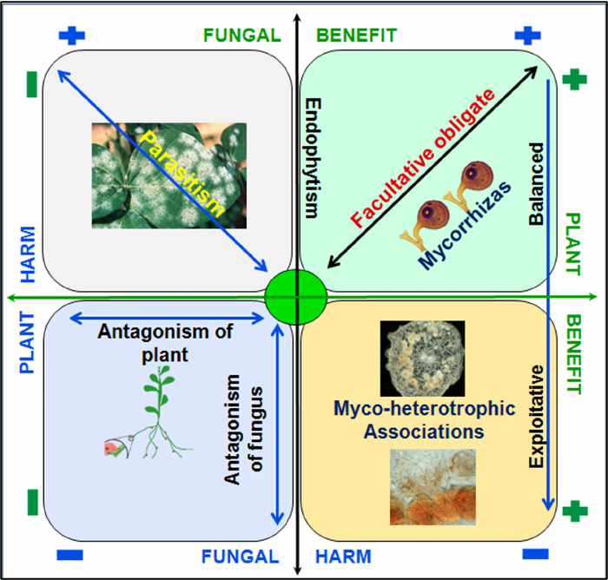
Fig 4.2 Plan-fungus symbiosis continuum spectrum; upper right is where both partners benefit, upper left the fungus is benefiting but the plant is being harmed (parasitism), lower right is where plants benefit but the fungus has reduced fitness, lower left depicts a relationship where neither partner is benefiting.

In Summary:

- Saprophytic fungi degrade dead organic materials
- Mutualistic fungi live in symbiosis with another organism where both members are benefiting
- Commensal symbiosis is when 2 organisms live together and only 1 partner is benefiting but the other partner is not harmed in any way
- Parasitic fungi steal nutrients from a living host organism

Chapter 5

Fungal Taxonomy and Systematics

Grower’s Notes:
- Taxonomy and classification is important to show how related different organisms are to each other
- Fungi are eukaryotic organisms closer related to animals than to plants
- 5 major phyla in kingdom fungi are Basisiomycota, Ascomycota, Glomeromycota, Zygomycota, and Chytridiomycota
- Fungal taxonomy is in a state of constant flux
- Water molds and slime molds are not true fungi

Taxonomy and systematics refer to the naming and relative relationship of any biological organism. Here we discuss how fungi are classified, named and, more importantly, how this system is changing and can be a source of confusion for the non-academic, farming community. This information will prove useful if trying to protect crops against particular pathogens and also for determining how closely one fungus is related to another. In particular, when trying to find a treatment (biological, chemical, or environmental) to reduce pathogen infection of a Cannabis crop.
Science has attempted to classify organisms in a hierarchical way, in order to help organize and make sense of nature. All extant organisms on earth that we know of have descended from a common ancestor, known as the last universal common ancestor (LUCA). Scientific systematics reflects the relation of organisms to other groups through this classification system. We can use this classification system to tell us some similarities and relatedness of fungi to other organisms in general terms.
The hierarchical classification follows the same arrangement for all living organisms. This classification begins with the most broad groupings of relatives, and gets more and more specific with every step of the way. As such, all organisms are sorted into one of three domains, then into clades, followed by kingdom, phylum, class, order, family, genus and, finally, species. Together, we may compile all of this information to create a ‘tree of life’ which helps us visualize the relatedness of all organisms. This tree contains all life on earth, from single-celled bacteria all the way up to the most evolutionarily derived organisms, including ourselves -Homo sapiens (Fig. 5.1).
Classification has generally been rooted in a concept of the ‘vertical’ transmission of heritable traits from parent to offspring, with lineages diverging over time as evolution imposes separations among populations of living beings. However, genes do not only move from parent to offspring. Genes may also move sideways during an individual's lifetime, or ‘horizontally’, and do not necessarily originate from a relative or even member of their own species. The result is a tree of life that has many fused branches which depart and recombine over time. For this reason, some modern biologists eschew the tree analogy for something more akin to a web (Doolittle, 2000). Horizontal gene transfer is particularly common at the ‘base’ of the tree among the prokaryotes. However the fused branches are evident today in eukaryotic organisms as well -all of whose cells are composed of previous free living bacteria ( mitochondria, chloroplasts) that are now entrapped in a derived archaea (the now eukaryotic cell). The nuclear genome of eukaryotes as well as its organelle genomes may also be mixed with a melange of individual genes and gene cassettes from other bacteria, archea, and viruses. Horizontal gene transfer is still commonplace among microbes, but also even occurs among the more derived eukaryotic species to this day. For instance the genes involved in psilocybin synthesis, usually present as a 20 Kb cassette, likely moved among diverse fungi via horizontal gene transfer (Reynolds et al, 2018). The nuclear genome among humans is also no less than 8 percent viral in ancestry, with some of the genes critical to our identity as mammals being viral in origin, including genes which organize the growth of placental cells during pregnancy.
Some scientists estimate that there may be somewhere around 5 million species of fungi in the world, about 70,000 of which have been described (Blackwell, 2011). Regardless of how many species of fungi there are, what we do know is that fungi are a very diverse group of organisms that are ubiquitous in nature. We still have much to learn about this fascinating Kingdom.
As we begin to attempt to identify different types of fungi, it is important to keep in mind what makes all fungi similar and also what makes a button mushroom different, from say, a morel mushroom. Macroscopically there are some clear differences. However, with the help of a microscope, there are features that easily separate out many of the various phyla of fungi. This will help out immensely when attempting to identify moldy fungi. Some fungi obscure their true identity from observers attempting to utilize physical features alone and require genetic study to differentiate.
The scientific names of species, known as their specific epithet, consists of the two most restricted levels of the categorical titles mentioned: genus and species. This naming system is referred to as binomial nomenclature and was pioneered by Carl Linnaeus; the same person who pioneered the hierarchical classification system. Linnaeus, working a century before the Theory of Evolution was to be elegantly described by Charles Darwin and Alfred Russel Wallace, was of the contemporary opinion that species were immutable and unchanging from their original creation. Therefore, Linnaeus's classification system was a taxonomy, concerned only with the naming of organisms, while grouping together those that appeared similar for ease of categorization.
Modern taxonomy now incorporates the Theory of Evolution to include not just diagnostic features of species phenotypic expressions, but also the relatedness of species, or its phylogeny, through time. This synthesis of taxonomy and evolutionary relatedness has resulted in the field of systematics.

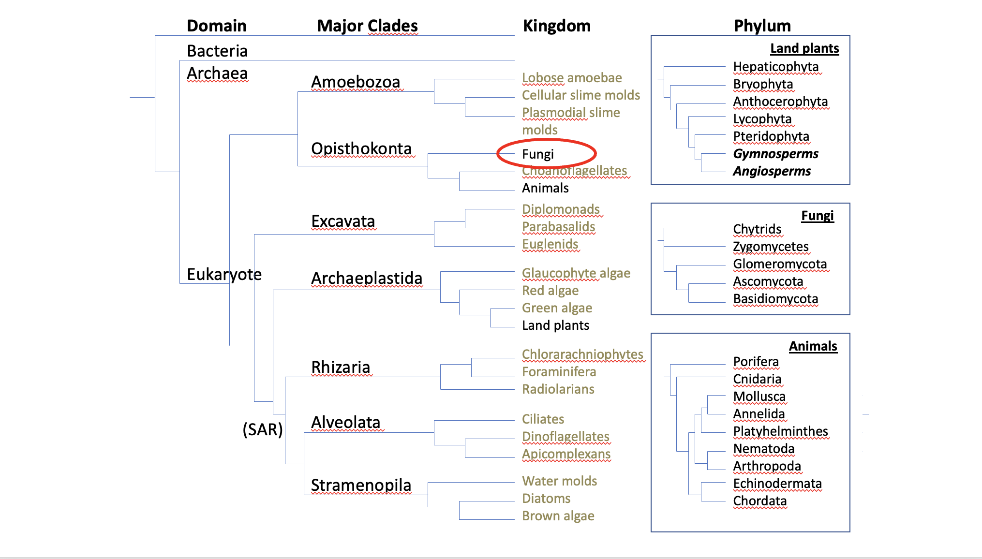

Figure 5.1. Example of a basic tree of life.

Depending on which classification scheme you read, there are 5-18 phyla in the Kingdom fungi. For our discussions, these include Basidiomycota, the club fungi; Ascomycota, the sac fungi; Mucoromycota (formerly ‘Glomeromycota’ and ‘Zygomycota’); Chytridiomycota, the mobile ‘little pot’ fungi; and finally the Microsporidia, unicellular parasites formerly thought to be non-fungi protists. The ‘Zygomycota’ have been discovered to be a polyphyletic grouping (not descended from an immediate common ancestor) and is no longer formally recognized as a phylum (Hibbet et al 2007, Spatafora 2016, Tedersoo et al. 2018). The term is still in popular usage and will serve as a useful grouping in this book. Similarly, ‘Glomeromycota’ was the former name of the Glomeromycotina, a subphylum in Mucoromycota (Bruns et al. 2017).
Ascomycota is home to many soil decomposers, ectomycorrhizal species, most plant endophytic fungi, as well as most of the dreaded plant and human fungal pathogens. Basidiomycota contains most of the species people recognize as ‘mushrooms;’ they often are responsible for primary decomposition of woody materials, though many form ectomycorrhizae with woody plant species and some species cause plant and human disease. The Mycoromycota comprise the arbuscular mycorrhizal fungi in the Glomeromycotina, in addition to the ‘Zygomycota’ fungi such as bread molds, post-harvest strawberry mold, as well as the newly transcribed Mucoromycotina Fine Root Endophyte mycorrhizae (Orchard et al 2016). Chytridiomycota (as well as bacteria and archaea) also assist in the breakdown of cellulolytic, lignin, chitin, and keratin based materials.
Although people have been studying and attempting to classify fungi for hundreds of years, fungal systematics is in a state of constant flux. Scientists and researchers frequently go back and forth on where certain fungal organisms belong on the tree of life. With the advancement of various molecular techniques, we are able to better estimate the relatedness of different fungi. However, molecular techniques themselves develop over time as our understanding increases, as does our understanding of how to interpret the resulting data. It is important to remember that these classification systems are our best current understanding of these organisms’ relatedness in nature. Current classifications are not sacrosanct. The names of species and our understanding of their placement on the tangled tree of life still change frequently.
The switch from physical features alone, to one that accounts for relatedness, is the cause of much confusion for people who suddenly learn a well-known species has been moved into a completely unrelated taxonomic grouping than previous. Many physical or chemical features among unrelated species have come to appear strikingly similar due to convergent evolution, a process where similar forms have arisen independently as a consequence of selection for a shared function. A commonly cited example in zoology is the striking similarity of body form of whales and dolphins, which are mammals, to that of sharks and other true fish. The same convergence in function also occurs at a physiological level among the chemistry of organisms. For instance, the relatively common occurrence of caffeine among unrelated plant species is due to convergent evolution, rather than horizontal gene transfer (Huang et all 2016). Similarly, in another surprising twist about the aforementioned magic mushrooms, some species of psilocybin producing fungi appear to have evolved the capability independently through convergent evolution, rather than acquiring the more common psilocybin synthesis cassette via horizontal gene transfer (McKernen et al. 2021).
With that in mind, we must accept that some fungi that we now know by certain names may be given a new name in the upcoming years. The result of these frequent name changes is that technically-defunct names for fungi may remain in circulation as synonyms, particularly for fungi that were widely known by names based on old taxonomic classifications. A prime example is the endomycorrhizal fungus Rhizophagus irregularis. Two decades after its official name change, this agriculturally-important fungus is still widely marketed under its defunct, but more popularly recognized name, Glomus intraradices. Keep this in mind as you learn fungal species names (see Index Fungorum at indexfungorum.org for up to date scientific names and listings of previous synonyms).
The two phyla to which all mushroom-producing fungi belong are the Basidiomycota and Ascomycota. In Basidiomycota, spores are borne-exterior, on a club-shaped structure called a basidium, typically in groups of four, whereas in Ascomycota, spores are developed inside a sac-like structure called an ascus, typically in groups of eight spores. Throughout our journey with mycology, we will see time and time again the spores and spore-bearing structures will aid us in identification.

Basidiomycota
The fungi of concern to farmers within Basidiomycota are primarily saprophytic fungi that degrade organic material and aid in nutrient cycling. These are often, but not always, mushroom-producing fungi. They can break down woody plant material from leftover crop residues and also herbaceous material. Basidiomycota are infrequent plant pathogens, though some are of concern to Cannabis farmers. The basidiomycete genera Rhizoctonia contains species that frequently cause root diseases. The infrequently encountered rust fungi, Aecidium cannabis, is also a basidiomycete.
Basidomycota have septate hyphae, often with clamp connections. Spores are borne externally on basidia. Often basidia are formed on special exposed surfaces of a fruiting body (hymenium). The gills of mushrooms are such a surface, and all gilled mushrooms are basidiomycetes.

Ascomycota
These include many mushroom-producing species, as well as most of the mold fungi. Many of these organisms are filamentous molds important in agriculture. Fungi such as Trichoderma, Aspergillus, Botrytis and Penicillium are all fungi belonging to this phylum. They will be found in most soils where any amount of organic matter is present.
Ascomycota have interior-borne, sexual spores produced in asci which are then discharged at maturity. Their hyphae is septate and they may live ectomycorrhizal, saprobic, and/or pathogenic lifestyles. Many “moldy” fungi rarely or never undergo sexual reproduction. Most asexual reproduction occurs via microscopic structures, which is one reason they often go unnoticed by the casual observer.

Glomeromycotina
Species belonging to the Glomeromycotina are among the most important symbionts of many plants, forming associations with over 80 percent of plants on land. The most common species encountered by Cannabis farmers include Rhizophagus intraradices and Funneliformis mossea (formerly Glomus intraradices and Glomus mosseae, respectively). All Glomeromycotina form arbuscular mycorrhizas. This is a growth form in which the fungus invades plant roots, even passing through cell walls (but not cell membranes) to form highly branched arbuscules (fig. 5.3). The large surface area of these arbuscules permits efficient transfer of nutrients between the fungus and its plant host. The plant may receive inorganic nutrients, such as phosphorus, and improved access to soil moisture, while the fungus receives energy rich organic carbon molecules (derived from carbon dioxide that has been fixed into carbohydrates during photosynthesis).
Therefore, the main role these fungi are playing for the plant is nutrient acquisition. In return the plant provides carbon in the form of sugars to the fungus. This relationship is more likely to form in nutrient depleted soils where either partner would be unable to survive on its own. In addition, plants infected with AMF may be more resistant to abiotic and biotic stressors (Brendett and Kendall 1988). While Ascomycetes, Basidiomycetes, and Mucoromycotina all form mycorrhizal association with some plants, currently only the members of the endomychorrizal Glomeromycotina are confirmed to form mycorrhizal associations with Cannabis. However, the newly described Mucoromycotina Fine Root Endophytes likely form such associations with Cannabis though this has not yet been formally described.
Glomeromycota have coenocytic hyphae and reproduce asexually via spores. Oftentimes these large spores bundle close to each other in the soil in a structure called sporocarps. Arbuscular Mycorrhizae Fungal spores are typically thick-walled full of nutrients along with many nuclei. Although their sexual state is unknown, it is possible that AMF do undergo some sort of sexual reproduction in the field that has not been documented.

‘Zygomycota’ (now the Mucoromycota and Zoopagomycota)

The historic phylum ‘Zygomycota’ is no longer formally recognized and has recently been split into the phyla, Mucoromycota and Zoopagomycota (Spatafora et al, 2016). Despite this, it can be useful to group and refer to them as ‘Zygomycota,’ due to the historic use of the term in literature, as well as morphological similarities among them. The ‘Glomeromycota’ are combined with the Mucoromycota in the current classification.
Mucoromycota are important saprophytes common in soils, occasional plant and animal pathogens, and also form both endophytic and mycorrhizal relationships with plants. Common bread mold, and the dog-poop fungus Pilobolus, belong to this phylum. Mucoromycota are common soil saprophytes. Non-ascomycetous molds are mostly members of the Mucoromycota.
The primary agricultural impacts of Mucoromycota plant pathogens occur on the fruit of caneberries and strawberries caused by fungi in the genera Mucor and Rhizopus. The precise nature of the mycorrhizal and endophytic relationships of fungi in this group are still not fully understood, though it is believed that members of this group may have been among the first fungal partners associated with the development of land plants (Bonfante and Venice, 2020). As human and animal pathogens, severe mucormycosis may cause severe disfiguring necrotrophic disease and death (Danion et al, 2015); Affected Cannabis may be a source of exposure to this pathogen among immunocompromised users.
The Zoopagomycota comprise parasites (often obligate), including the subphyla Entomophthoromycotina. Fungi within Entomophthoromycotina are mostly pathogens of arthropods as well as soil-borne saprophytes. Entomophthoromycotina contains fungi with agricultural potential as bioinsecticides of important insect pests, such as Pandora neoaphidis, a parasite of aphids. Another grouping of agriculturally important entomopathogenic (insect pathogenic) fungi are within the Hypocreales; this group is nestled within the Ascomycota and has a distinct evolutionary history from the Entomophthoromycotina.
‘Zygomycota’ have translucent (hyline), coenocytic hyphae and have sporangiophores containing the spores within a membrane. When sexual reproduction occurs, a single celled diploid zygote is formed, within which meiosis occurs to form eight haploid spores. Entomophthoromycota also all have forcibly discharged conidia, and homothallic zygospore formation (Gryganskyi et al, 2013). Homothallism, a subject to be elaborated on in the next chapter, refers to an individual fungus's ability to mate with itself (selfing), without needing another individual.

Chytridiomycota
Chytridiomycota are aquatic fungi, including within the films of moisture found in soils, that are parasitic or saprobic. The chytrids represent a basal fungal taxa that have retained the ancestral opisthokont zoospore mobility. Zoospores are single cells with a single, posterior flagella- the same basic morphology as human, opisthokont sperm. While in this stage, chytrids can swim in their aquatic environment to find an appropriate substrate to eat, and, if they perform sexual reproduction, another individual with which to mate.
Parasitic chytrids may attack microscopic organisms, such as algae and protists, however, some animals and plants are also affected. Batrachochytrium dendrobatidis (Berger et al. 1998), and B. salamandrivorans (Martel et al, 2013) affect amphibians. The spread around the world of B. dendrobatidis to new habitats, exposing pathogen-naive amphibian populations, has been implicated in the decline of over 500 species including at least 90 extinctions (Scheele et al, 2019). Among plants, the economically important potato wart disease is caused by the chytrid, Synchytrium endobioticum.
No chytrids have been reported to cause disease among Cannabis (however this is a very understudied crop, paired with an understudied phylum of fungi, so keep an eye out for a discovery.) The saprobic activity of chytrid fungi is more relevant to Cannabis farmers than potential plant disease. In this role chytrids specialize in degrading particularly stubborn materials in the environment, such as keratin, chitin, and pollen. Chytrids also serve to weather rocky parent material to form soil, particularly in nutrient-poor environments. Intriguingly the chytrid genus, Rhizophlyctis, generally considered to be soil dwelling, was identified using molecular techniques on dispensary Cannabis flower (Thompson et al, 2016). There may be unknown symbiosis among chytrid species and Cannabis occuring in the aerial parts of the plant, or this was a result of soil contamination of the final product.

Microsporidia
Microsporidia are unicellular parasites that reproduce within the cell of its host. Once classified within the defunct phylum Protista, they are now known to be related to fungi. Microsporidia affect a wide range of invertebrate and vertebrate hosts, including humans (microsporidiosis) and insects. Generally of little concern to plant agriculture, they may prove useful as biocontrol agents in the future against various insects of concern. They tend to cause slow diseases and reduce population fecundity over time. Therefore, they may be best suited for long term management strategies in the future.
Microsporidians reproduce by forming unicellular spores inside the body of the host, which can then survive inside or outside the host organism. In addition to reproducing by spores, microsporidians share several other features with typical fungi, including a cell wall made of chitin. These obligate parasites lack mitochondria and are some of the smallest eukaryotes.

‘Deuteromycota’
The ‘Deuteromycota’ are an artificial grouping of filamentous fungi that exist in the asexual (anamorphic) state. This superficial grouping is useful for characterizing these organisms based on form and function. Prior to the invention of molecular techniques, fungi were primarily classified based on their sexual structures. However, since certain fungi did not produce sexual reproductive structures in vitro , scientists were unsure which group to place these organisms in. Therefore, mycologists created a new group for the ‘imperfect fungi’ named deuteromycota.
Most of these species are Ascomycota, though Zygomycota and Basidiomycota also may be classified as ‘Deuteromycetes.’ Many of these fungi cause disease in animals and plants, therefore creating a giant economic impact.
Again, this classification scheme is based solely on morphological features and mainly the lack of reproductive structures. Therefore this grouping does not indicate the true genetic relatedness of these fungi but is still useful for relaying information about the organism's physical features. Many mycologists still use this classification method out of ‘convenience and tradition’ (Volk 2013).

The Non-Fungi
Oomycota
Despite their common name “water-molds,” Oomycota are not fungi, they are not even Opisthokonta. Rather they are Heterokonts, with gametes that have two differing anterior flagella, rather than a single posterior flagella. This places them far from fungi, phylogenetically. Rather they are most closely related to photosynthetic algae, including kelp.
Nonetheless, they are fungal-like organisms which grow as filamentous, aseptate hyphae and reproduce via mobile zoospores and resting oospores. Some oomycota are important agricultural pests of Cannabis, including Pythium species, a common cause of damping off. Other Oomycetes are hyperparasites of plant pathogens. For instance, Pythium oligandrum has recently been licensed for use as a biocontrol agent active against a wide range of soil-borne fungal and oomycete pathogens, including Rhizoctonia solani, Sclerotinia sclerotiorum, Botrytis cinerea, and species of Fusarium, Phoma, Pythium, Alternaria, and Verticillium (EPA fact sheet).

Actinobacteria

The actinobacteria are gram positive bacteria. These are prokaryotes and are not closely related to fungi. However, actinobacteria have filamentous growth, often form extensive ‘mycelial’ networks, are facultative anaerobes and often fill similar ecological roles as fungi. Since fungi were historically grouped based on morphological features, scientists thought these filamentous bacteria may have been the ‘missing link’ between fungi and bacteria. Molecular techniques have proved this false.
Actinobacteria include the important agricultural genus Streptomyces and nitrogen fixing genera, including Frankia. In addition to fixing nitrogen, actinobacteria are decomposers of organic matter that thrive in low oxygen conditions. These organisms are commonly found in ‘ashy layers’ of hot compost piles and are often responsible for the ‘earthy smell’ in the forest after a rainstorm.
Taxonomy, Existence, and Sex
The diversity of fungal and non-fungal groups listed here betrays a shared natural history from which they, and all life on Earth, emerged. Forged through generations of competition, cooperation, and coexistence to persist -to the present day and maybe beyond- in their current complexities. The key to persistence isn’t immortality in a static form. It is variation and adaptability. One of the most successful mechanisms which generates evolutionary novelty over time is sex.
Sexual recombination permits whole sets of genomes from the donor parents to interact in the next generation. Crossing-over and mutations then create yet entirely new genome sets in the next generation, and so on. Fungal lineages have developed differing strategies for sexual reproduction. Among the “deuteromycetes” unknown to produce sexual spores, some have developed alternate mechanisms for developing variation, which we will delve into next.

In summary:
- Taxonomy and classification is important to show how related different organisms are to each other
- Fungi are eukaryotic organisms closer related to animals than to plants
- 5 major phyla in kingdom fungi are Basisiomycota, Ascomycota, Glomeromycota, Zygomycota, and Chytridiomycota
- Fungal taxonomy is in a state of constant flux
- Water molds and slime molds are not true fungi

